**Exp 2 (prog 1)**

**Program on accepting input through keyboard**

Write a program to create a class Student with data ‘name, city and age’ along with method printData to

display the data. Create the two objects s1 ,s2 to declare and access the values.

//Write a simple input program

class Student{

    String name, city;

    int age;

    static int m;

    void printData(){

        System.out.println(&quot;Student name = &quot; + name);

        System.out.println(&quot;Student city = &quot;+ city);

        System.out.println(&quot;Student age = &quot; + age);

    }

}

public class exp2_1 {

    public static void main(String[] args) {

        Student s1 = new Student();

        Student s2 = new Student();

        s1.name =&quot;Amit&quot;;

        s1.city = &quot;Dehradun&quot;;

        s1.age = 22;

        s2.name =&quot;Kapil&quot;;

        s2.city = &quot;Delhi&quot;;

        s2.age = 23;

        s2.printData();

        s1.printData();

        s1.m = 20;

        s2.m = 22;

        Student.m = 27;

        System.out.println(&quot;s1.m = &quot; + s1.m);

        System.out.println(&quot;s2.m = &quot; + s2.m);

        System.out.println(&quot;Student.m = &quot; + Student.m);

    }

}

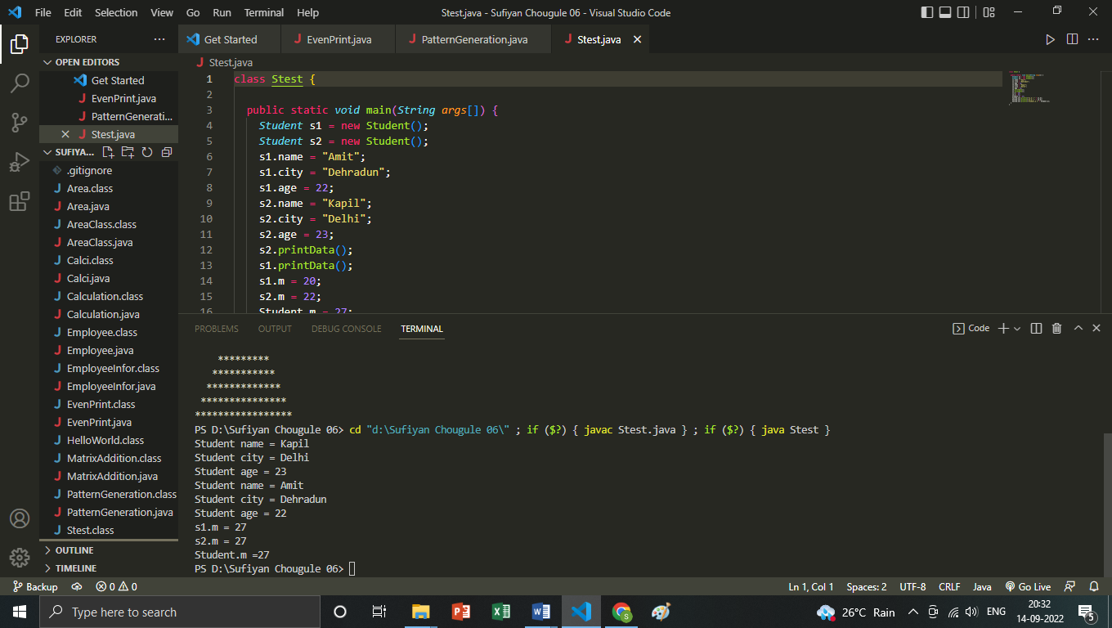

Program 2

Program on accepting input through keyboard.

Write a program to create a class Student2 along with two method getData(),printData() to get the value

through argument and display the data in printData. Create the two objects s1 ,s2 to declare and access

the values from class STtest

//Program on accepting input through keyboard.

//prog 2

class Student2

{ private String name, city;

private int age;

public void getData(String x, String y, int t)

{

name=x; city=y; age =t;

}

public void printData()

{

System.out.println(&quot;Student name =&quot;+name);

System.out.println(&quot;Student city =&quot;+city);

System.out.println(&quot;Student age =&quot;+ age);

}

}

public class exp2_2 { public static void main(String args[])

{

Student2 s1=new Student2();

Student2 s2=new Student2();

s2.getData(&quot;Kapil&quot;,&quot;Delhi&quot;,23);

s2.printData();

s1.getData(&quot;Amit&quot;,&quot;Dehradun&quot;,22);

s1.printData();

}

}

